Split View Exercise

- Identification: Identify the parts of MS Word window.
1
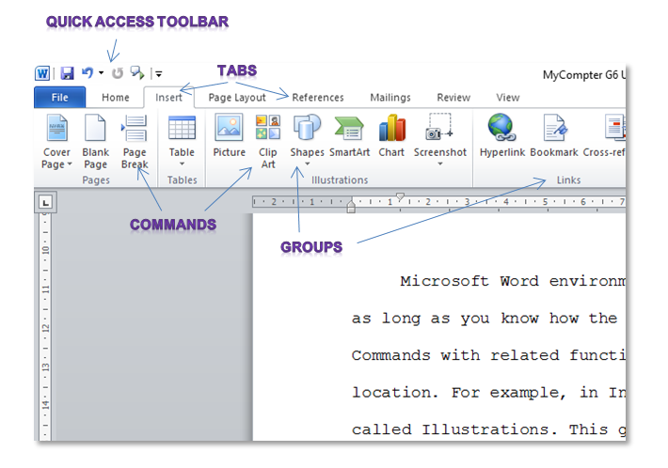
2

4
3

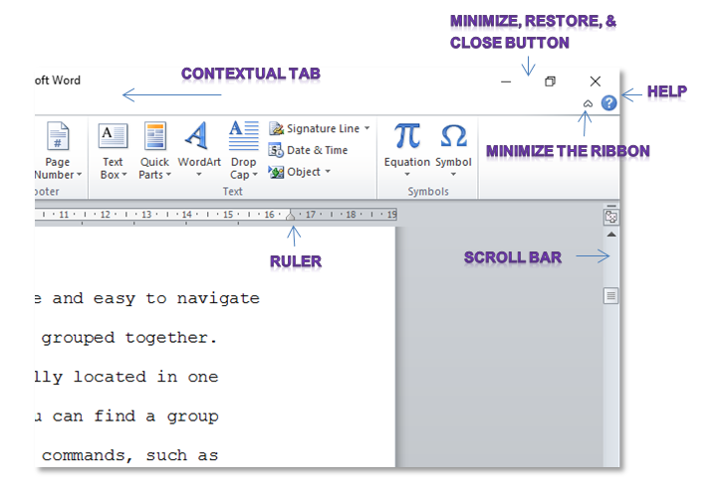
6

7
5

8

10
9

WORD BANK

Quick Access Toolbar
Tabs
Commands
Groups
Title bar
Minimize/Restore buttons
Help
Minimize/Hide the Ribbon
Ruler
Scroll bar

