Friendly Hiking Destinations near Manila

Our country is home to plenty of mountains where anyone can get the best view of nature. Here are some of the friendly hiking destinations near Manila.

- Mount Samat is a historic mountain in the town of Pilár, Province of Bataan, in the Republic of the Philippines. Located near its summit is the Mount Samat National Shrine, a national shrine dedicated to the fallen Filipino and American fallen during World War II. (https://en.wikipedia.org/wiki/Mount_Samat)

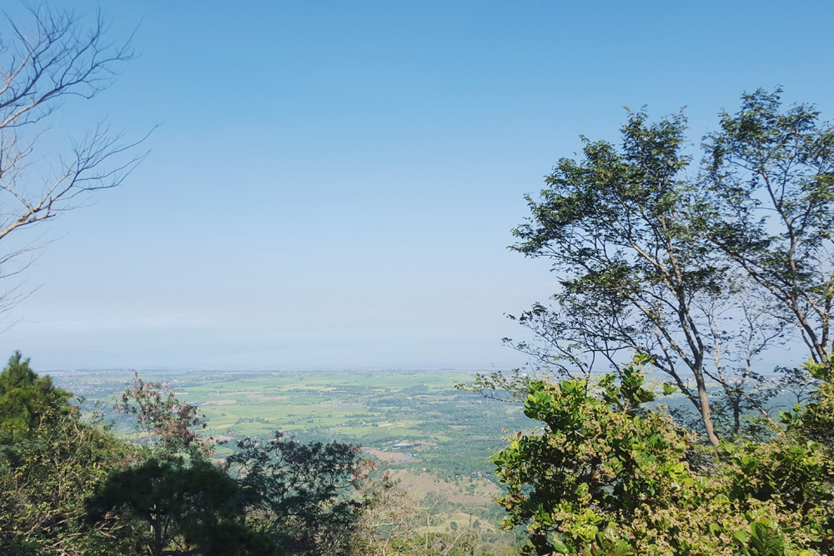
Picture A. Mount Samat (Bataan)

- Mount Pinatubo is an active stratovolcanic caldera in the Zambales Mountains, located on the tripoint boundary of the Philippine provinces of Zambales, Tarlac and Pampanga, all in Central Luzon on the northern island of Luzon. https://en.wikipedia.org/wiki/Mount_Pinatubo
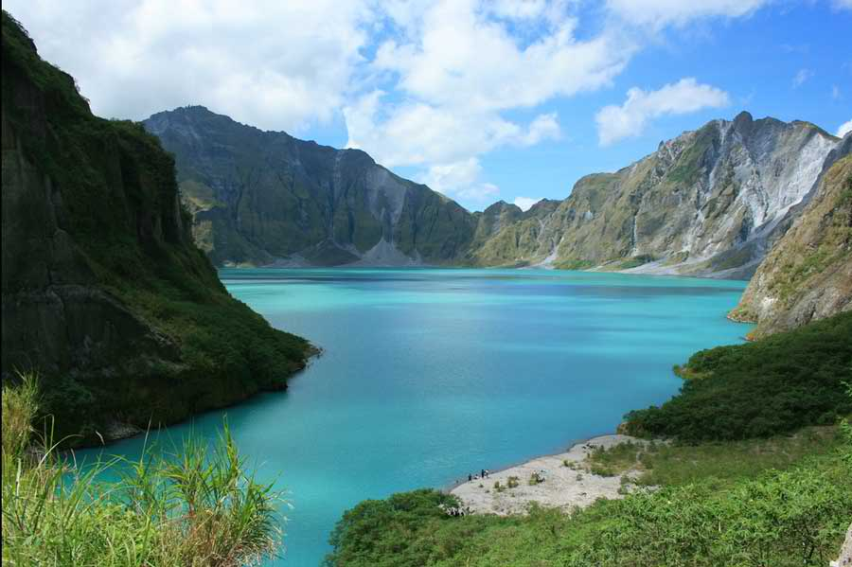
Picture B. Mount Pinatubo (Zambales)

- Pico de Loro was first named by Spanish sea-farers which means "Parrot's Beak" as its pointed summit resembles the shape of a parrot's beak from afar and it is commonly used as a signal by sea-farers to turn east to get to Manila Bay. https://en.wikipedia.org/wiki/Mount_Pico_de_Loro

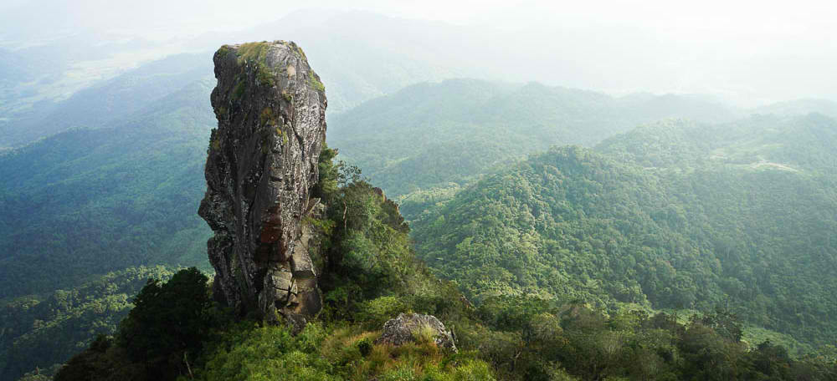
Picture C. Pico de Loro (Maragondon, Cavite)

