APPLE CHEDDAR CASSEROLE

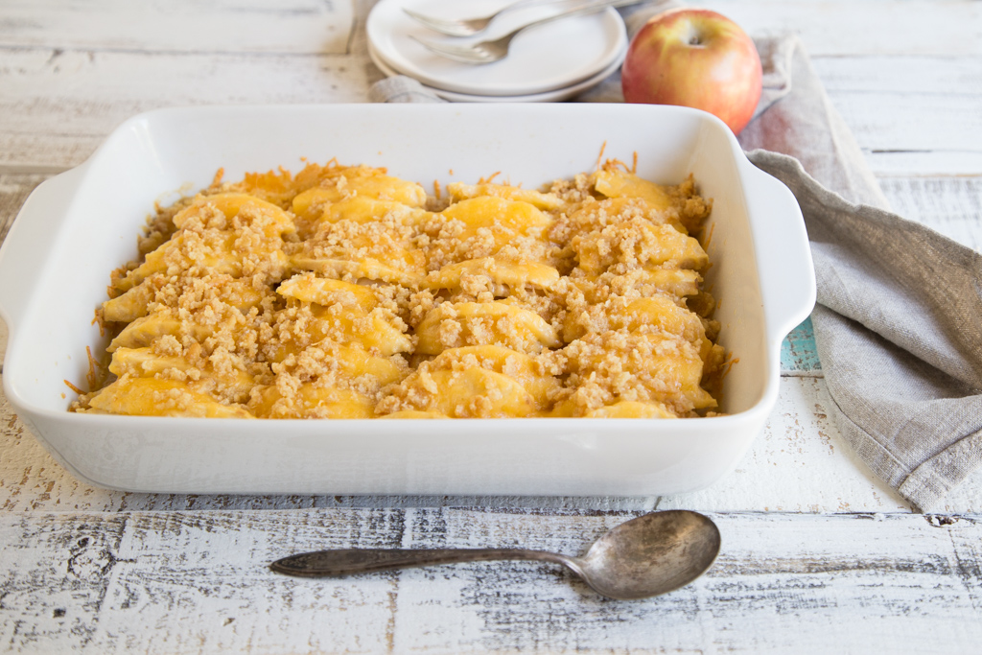

Ingredients
- 5 Fuji* apples, peeled, cored and sliced
- 1/3 cup white granulated sugar
- 1/4 cup 100% apple juice
- 3 tablespoons all-purpose flour
- 2 cups shredded cheddar cheese
- 4 tablespoons unsalted butter, melted
- 15 round butter crackers, crushed into crumbs

Directions
- Preheat oven to 375 degrees F. Spray 3-quart casserole dish with non-stick cooking spray.
- Layer apples in bottom of casserole dish. In small bowl, whisk together sugar and apple juice. Slowly whisk in flour until smooth. Pour over apples.
- Sprinkle cheese evenly over apples. In small bowl, stir together melted butter and cracker crumbs. Scatter crumbs evenly over cheese.
- Bake 18 to 20 minutes, until apples are tender and cheese around edges begins to brown. Serve warm.
Source: http://usapple.org

